**ECON 1000 – Contemporary Economic Issues**

*Observations on Inflation and Unemployment Rates in the United States* **“Measuring Macroeconomic Outcomes”**

# Relevant Readings from the Required Textbooks:

Chapter 9, *Observations on Inflation and Unemployment Rates in the United States*

# Definitions and Concepts:

* **inflation rate** – the rate at which the overall price level increases on an annual basis
* **deflation** – a general decrease in the level of overall prices (i.e., a realization of a negative inflation rate)
* **hyperinflation** – an extremely high rate of inflation, generally above 100% per year
* **unemployment rate** – the percentage of the labor force that is currentlyunemployed
  + **Misery Index** – economic indicator created by Arthur Okin, calculated by simply adding together the annual inflation rate and the unemployment rate

# Comparisons of Inflation Rates and Unemployment Rates:

2015 Inflation Rates: (“CIA World Fact Book”)

| Bulgaria | – 1.1% | Norway | 2.2% |
| --- | --- | --- | --- |
| Finland | – 0.2% | Mexico | 2.7% |
| France | 0.1% | Hong Kong | 3.0% |
| United Kingdom | 0.1% | Chile | 4.3% |
| Japan | 0.8% | India | 4.9% |
| Canada | 1.1% | Brazil | 9.0% |
| China | 1.4% | Russia | 15.5% |
| Australia | 1.5% | Argentina | 27.6% |

2015 Unemployment Rates: (“CIA World Fact Book”)

|  |  |  |  |
| --- | --- | --- | --- |
| Singapore | 2.0% | Brazil | 6.4% |
| Hong Kong | 2.9% | Canada | 6.9% |
| Japan | 3.3% | Sweden | 7.4% |
| Norway | 4.4% | France | 9.9% |
| United Kingdom | 5.4% | Italy | 12.2% |
| New Zealand | 5.8% | Spain | 22.5% |

# U.S. Inflation Rate Post WW-II:

* Annual Inflation Rate (observed monthly):
* January 1948 through December 2015 (816 months):
  + Mean = 3.58%
  + Median = 2.96%
  + Maximum = 14.76% (March 1980)
  + Minimum = –2.87% (July 1949)
* 0.73% in December 2015 => 48th straight month with a value below the median of 2.96%

Table 9-1

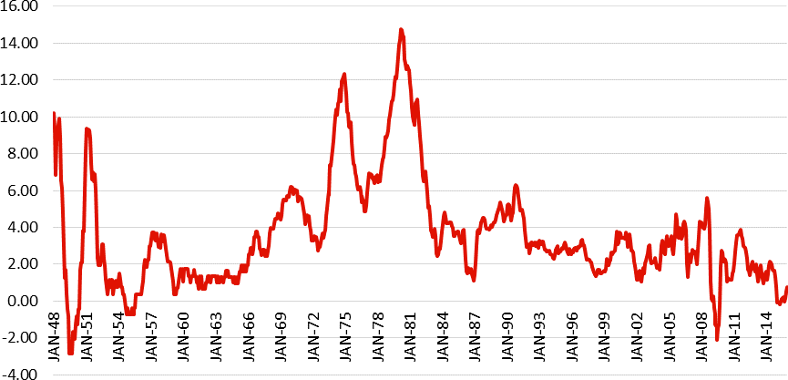

* Negative rate in 40 of these 816 months
  + Most recent deflation: September 2015 (plus 5 other months in 2015, Jan. 2015 through May 2015)
* **“The Great Inflation”** – period of abnormally high inflation rates from early 1970’s through early 1980’s
  + Above 6% in 99 of the 108 months (91.7% of months) between August 1973 and July 1982
  + Above 6% in only 11 of the 660 “other months” (1.7% of months) from Jan. 1952 to Dec. 2015

# U.S. Unemployment Rate Post WW-II:

* Unemployment Rate (observed monthly):
* January 1948 through December 2015 (816 months):
  + Mean = 5.82% and Median = 5.6%
  + Maximum = 10.8% (Nov. and Dec. 1982)
  + Minimum = 2.5% (May and June 1953)
* 5.0% in December 2015

Table 9-2

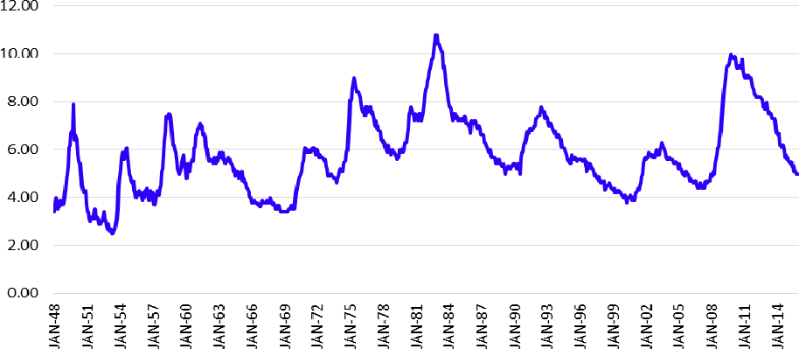

* Instances of rate “Above 8%” (since January1948)…
  + January 1975 to December 1975 (12 months)
  + November 1981 to January 1984 (27 months)
  + February 2009 to August 2012 (43 months)
* Below 8% in every month from Feb. 1984 to Jan. 2009 (300 consecutive months)
* Instances of rate “Above 10%”:
  + Oct. 2009 (1 month)
  + Sept. 1982 to June 1983 (10 months)
* Inflation Rate => three distinct periods…
  + Low rate: January 1952 through July 1973
  + High rate: August 1973 through July 1982
  + Low rate: August 1982 through December 2015
* Unemployment Rate => four distinct periods…
* Low rate: January 1948 through September 1974
* High rate: October 1974 through August 1994 (3)Low rate: September 1994 through July 2008 (4)
  + - High rate: August 2008 through December 2015
* Overlap of “high inflation” and “high unemployment”… => from October 1974 through July 1982, the U.S. economy experienced simultaneously high inflation and unemployment…

# Misery Index:

**Misery Index** – economic indicator created by Arthur Okin, calculated by simply adding together the annual inflation rate and the unemployment rate

* Monthly values, from January 1948 to December 2015:
  + Low value: 2.97 in July 1953
  + High value: 21.98 in June 1980
  + Average value: mean of 9.40; median of 8.66
  + 5.73 in December 2015
* Table 9-3

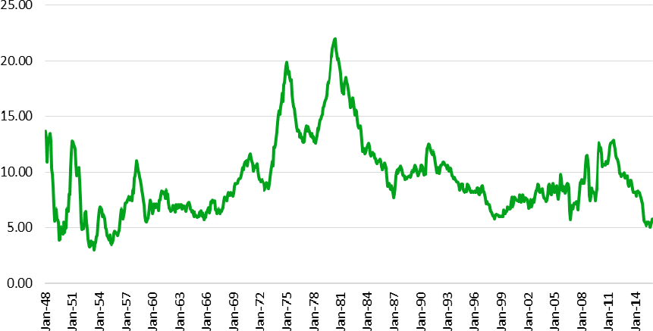

Misery Index value above 12.50:

* + 132 of 816 months between Jan. 1948 and Dec. 2015 (only 16.17% of the time)
    - not common
  + Most recently, 5 straight months from May 2011 through September2011
  + **“The Great Misery”** – period of time from November 1973 through June 1983 when the value of the Misery Index was 12.50 or higher in every single month
    - 116 consecutive months
    - above 12.50 in only 16 of 700 “other months” from Jan. 1948 to Dec. 2015 (i.e., 2.29% of the time)

# Multiple Choice Questions:

1. _________is an extremely high rate of inflation, generally above 100% per year
2. deflation.
3. hyperinflation.
4. unemployment.
5. none of the above is correct.
6. A first-draft college basketball star who has a month off before reporting to his new NBA team is an example of
7. frictional unemployment.
8. structural unemployment.
9. cyclical unemployment.
10. technological unemployment.
11. A steelworker who has been laid off during a recession is an example of
12. frictional unemployment.
13. seasonal unemployment.
14. cyclical unemployment.
15. search unemployment.
16. Which of the following statements about seasonal unemployment is true?
    1. It is likely to be associated with jobs that are affected by changes in the weather.
    2. It is likely to be affected by changes in consumer preferences.
    3. It results primarily from downturns in economic activity.
    4. It is the type of unemployment associated with discouraged workers.
17. This type of unemployment arises as one of the worst effects of a recession.
    1. Seasonal unemployment
    2. Static unemployment
    3. Cyclical unemployment
    4. Frictional unemployment
18. When Karen Baker finished college, it was three months before she found a good job. During this time between graduation and her first working day, she was considered
19. cyclically unemployed.
20. frictionally unemployed.
21. frequently unemployed.
22. structurally unemployed.
23. The official unemployment rate is
24. the number of unemployed people divided by the number of employed people.
25. the number of unemployed people divided by the total size of the population.
26. the number of unemployed people divided by the size of the non-institutionalized population.
27. the number of unemployed people divided by the size of the labor force.
28. Inflation is defined as
29. any decrease in the general price level.
30. the rate at which the overall price level increases on an annual basis
31. a sustained decresea in relative prices.
32. an increase in the prices of specific products.
33. The “Great Misery” refers to the period of time when
34. George W. Bush was President, when the U.S. Federal budget deficit increased by 234%.
35. abnormally high inflation rates were realized from the early 1970s through the early 1980s.
36. Barack Obama was initially President, when the unemployment rate was above 20% for 17 consecutive months from February 2009 through June 2010.
37. the sum of the unemployment rate and inflation rate was 12.50 or higher for 116 consecutive months from November 1973 through June1983.
38. The “Misery Index”
39. is an economic indicator created by Arthur Okin.
40. is computed by multiplying the unemployment rate by the inflation rate.
41. measures the fraction of population that is clinicallydepressed.
42. More than one (perhaps all) of the above answers is correct.

Please use the table below for Q-11-12

| *Do you currently have a job?* | **Type A** | **Type B** | **Type C** | **Type D** |
| --- | --- | --- | --- | --- |
| Yes | Yes | No | No |
| *Are you currently seeking a job?* | No | Yes | Yes | No |
| *Number of People of this type* | 700,000 | 220,000 | 80,000 | 600,000 |

1. There are people in the labor force of this society.

A. 700,000

B. 920,000

C. 1,000,000

D. 1,600,000

1. This society’s Unemployment Rate is .

A. 4.25%

* 1. 5%
  2. 8%
  3. Cannot be computed from the information provided in the table.

Answer Key

1. B

2. A

3. C

4. A

5. C

6. B

7. D

8. B

9. D

10. A

11. C

12. C